RFQ Process For Boughtout Items

- Select the session Enquiry In Progress.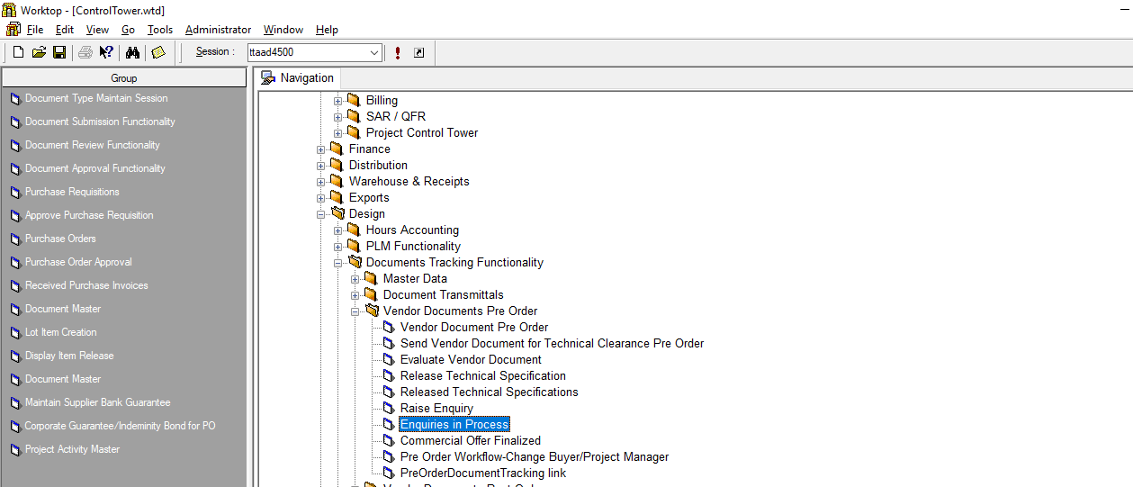
Click this Session

- The Buyer will be able to see the Released specification in the window that opens up. Click on Raise Enquiry button.
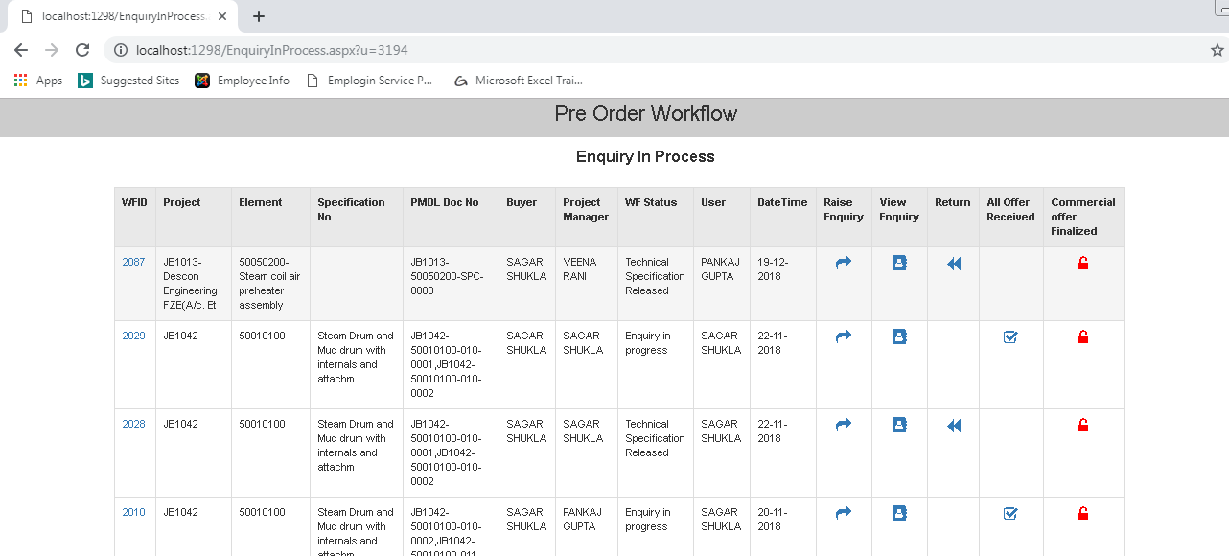
Click on Raise Enquiry
Released Specification

- The following screen opens up with previously entered data populated as shown.
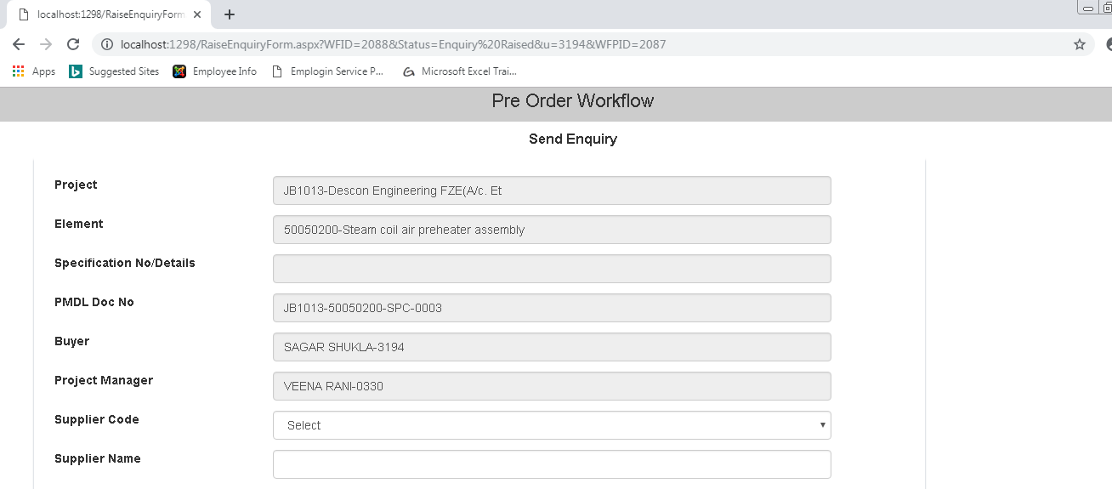
Populated Data

- Feed the details in the Blank Fields as shown & then click on attachment.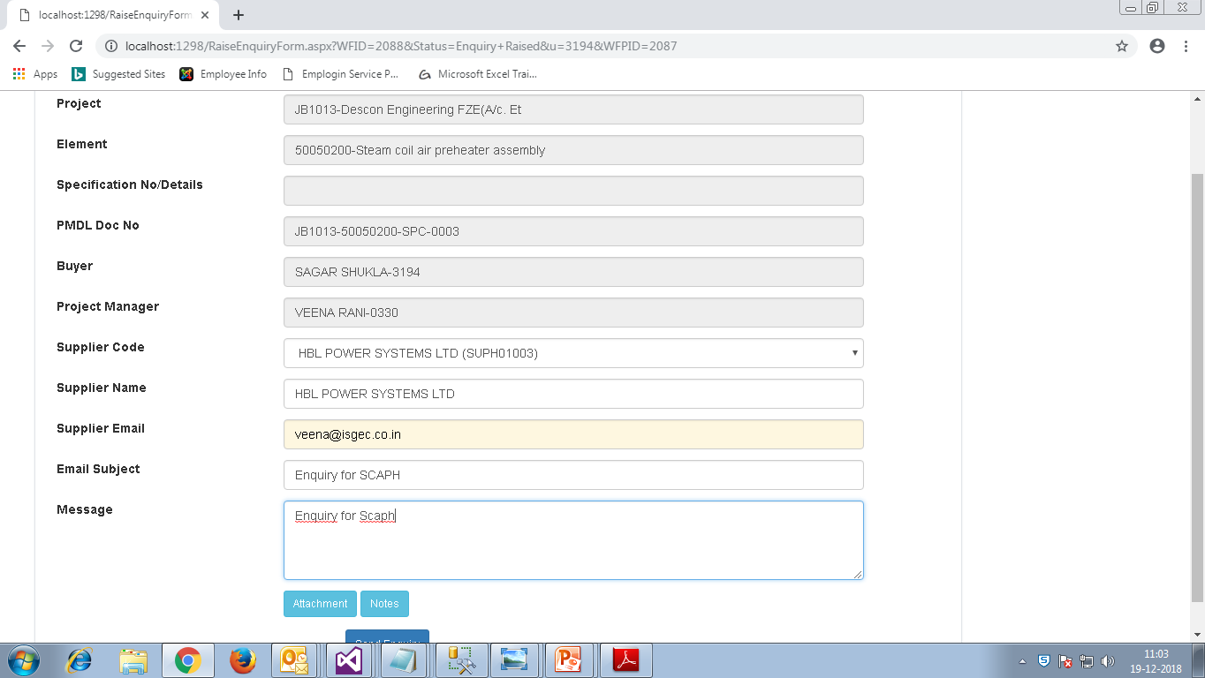
Click on attachment
Feed Details

- In the screen that opens up attach any additional Document to be sent to Vendor &then Exit the screen.
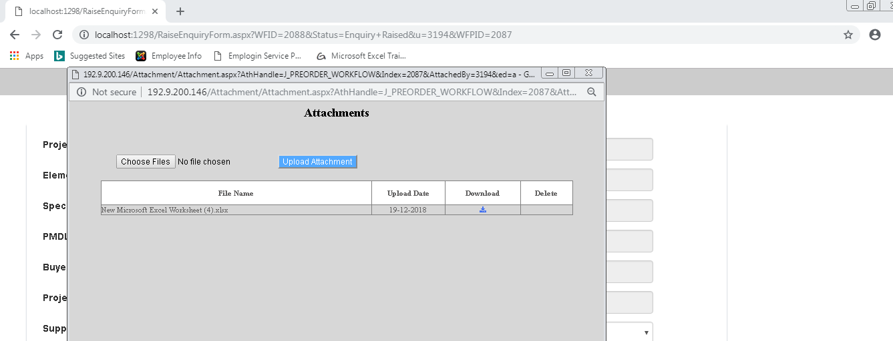
Upload attachment
Give Path of File To attach
- Click on Send Enquiry, an Email alert with Link is send to the Vendor.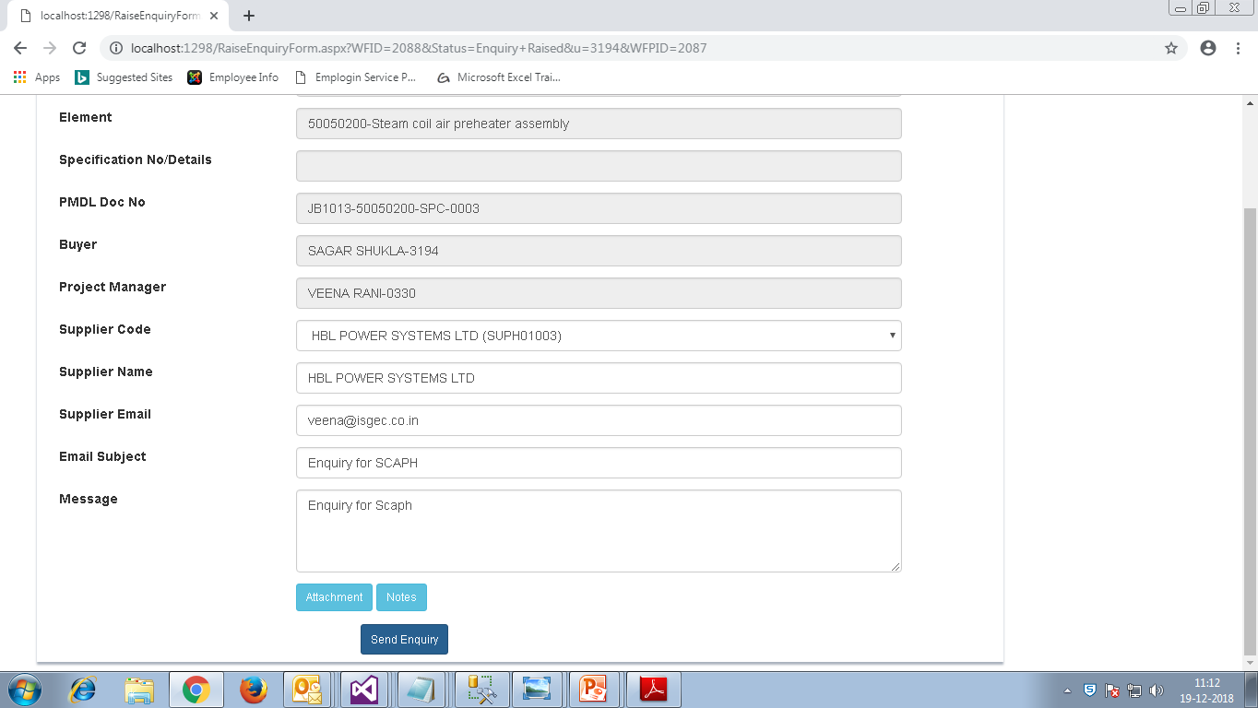
Send Enquiry

- In the Screen that opens up click on the link as shown.
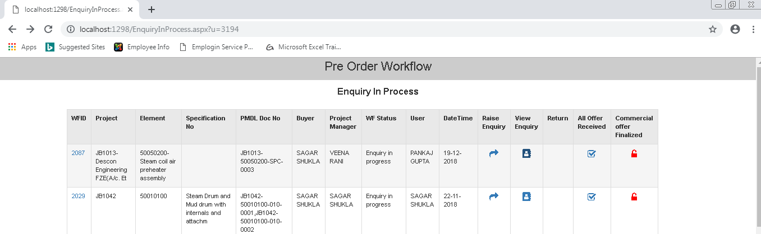
Click View Enquiry

- This screen will show the Number of Enquiry send to vendors then Exit this screen.
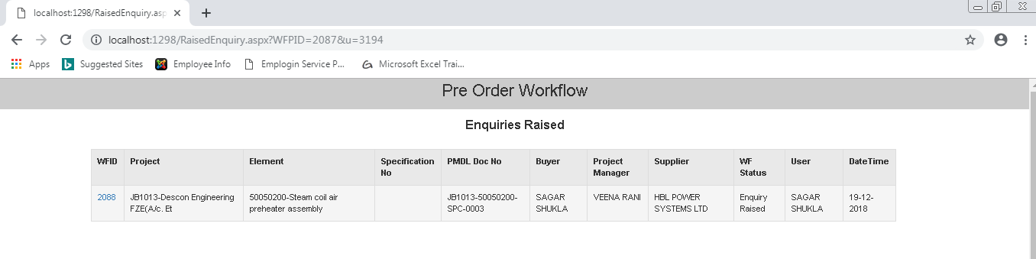
Enquiry send to Vendors

- Repeat this Process to raise Multiple Enquiry to different Vendors.

